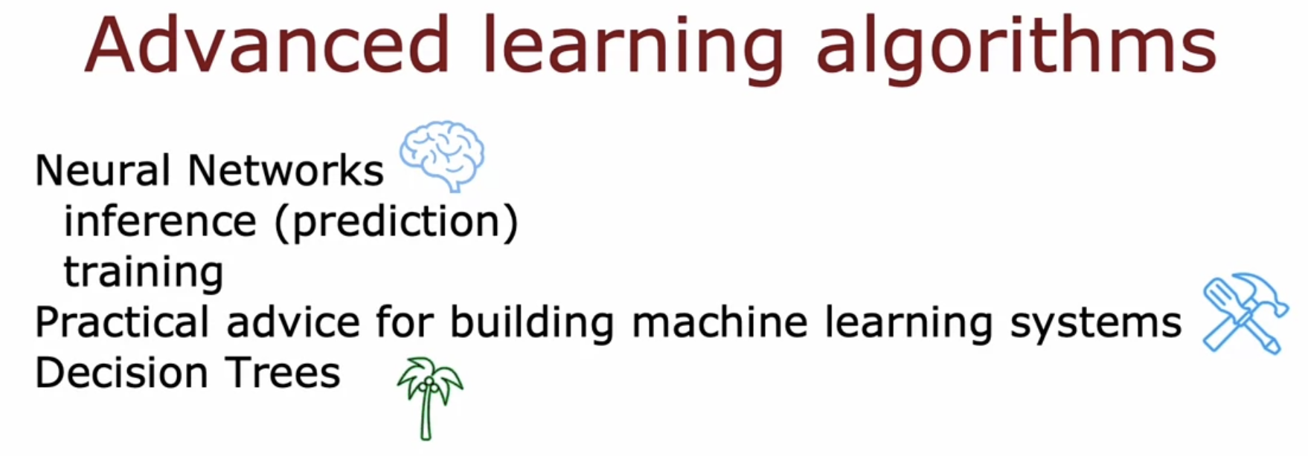

# **Neurons and Brains**

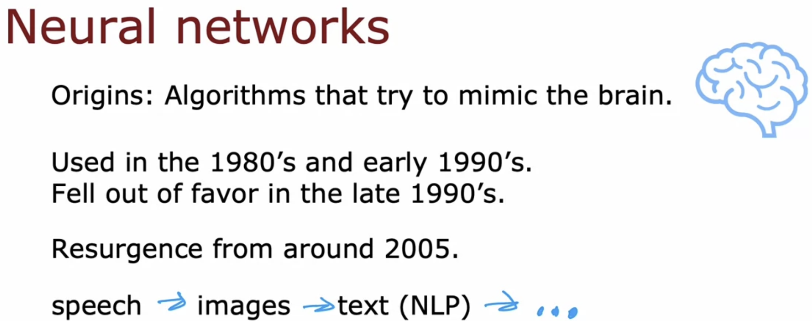

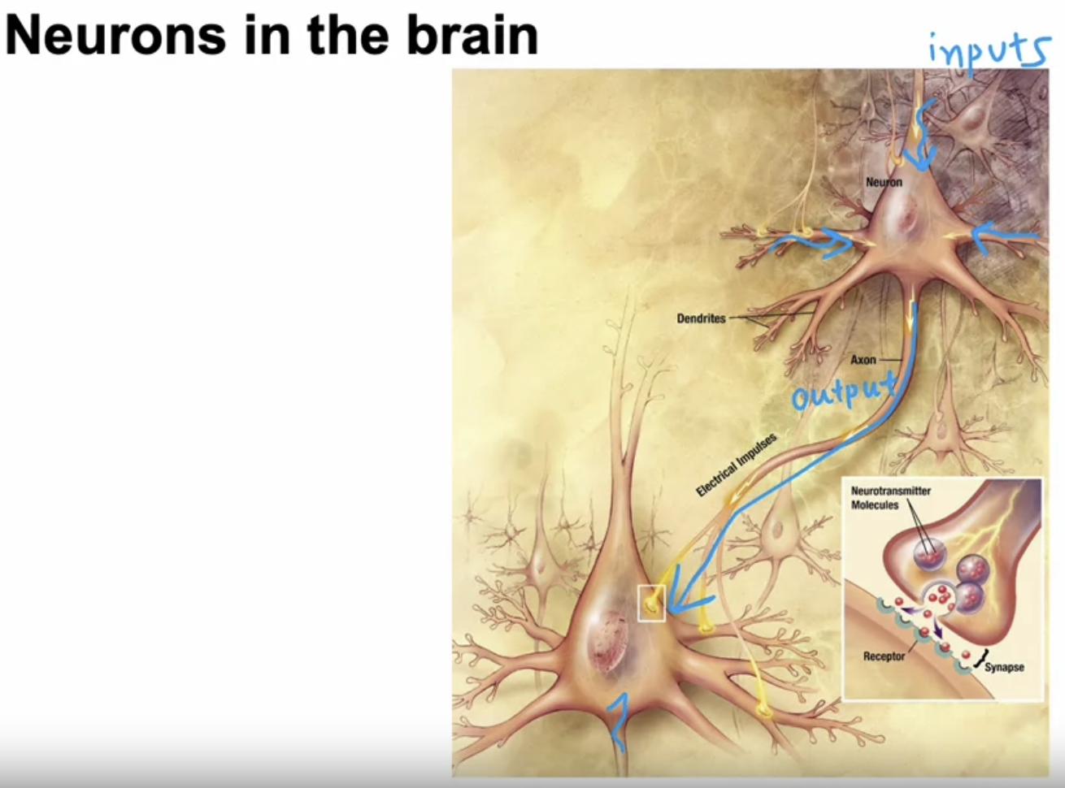

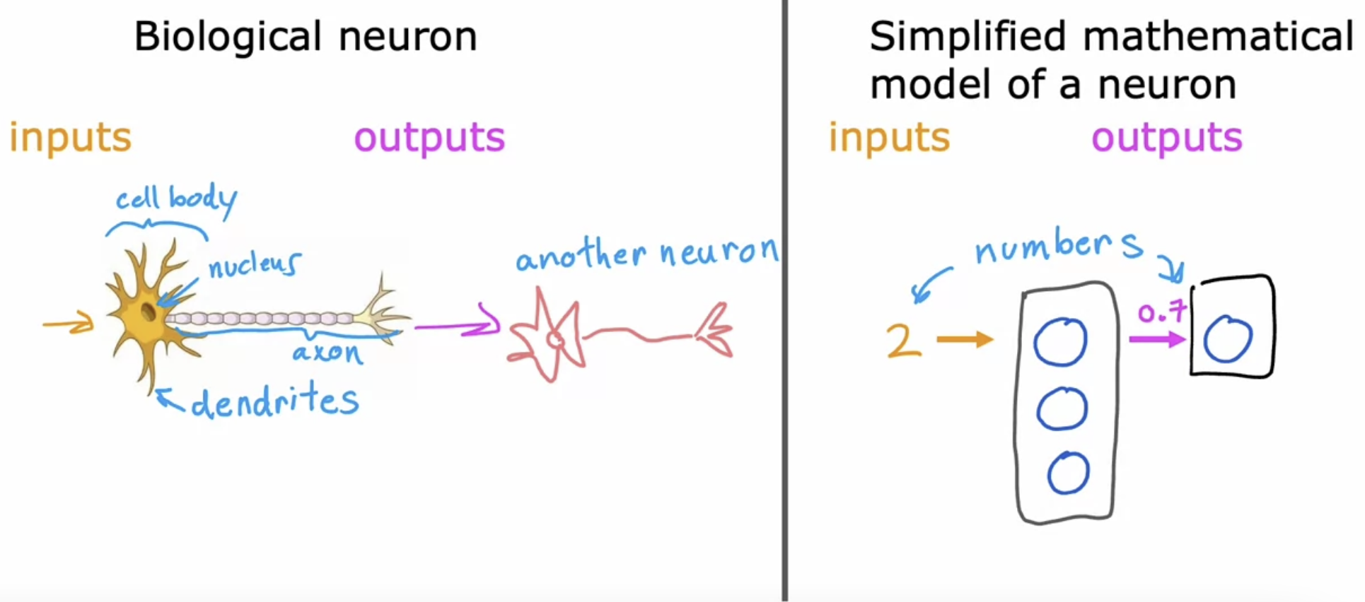

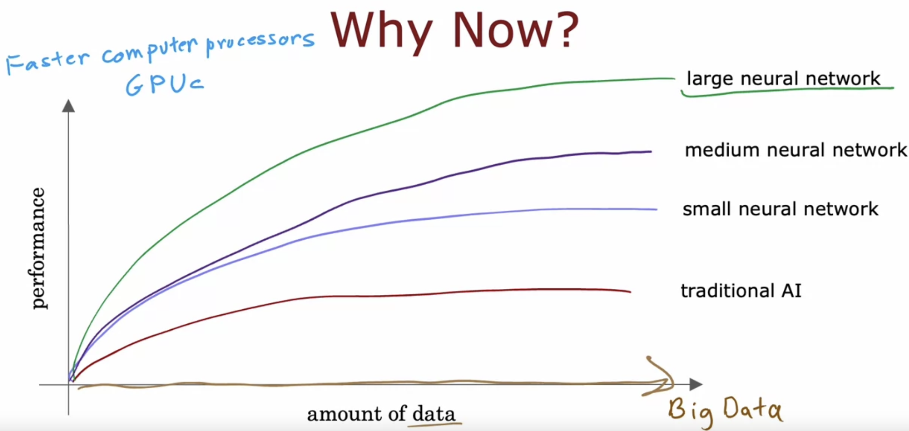

# **Demand Prediction**

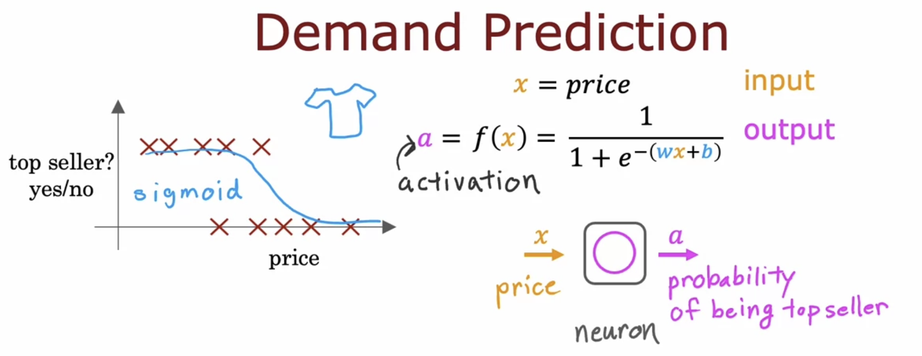

The term **a** stands for activation, and it's actually a term from neuroscience, and it refers to how much a neuron is sending a high output to other neurons downstream from it.

It turns out that this logistic regression units or this little logistic regression algorithm, can be thought of as a very simplified model of a single neuron in the brain.

Where what the neuron does is it takes us input the price x, and then it computes this formula on top,

and it outputs the number a, which is computed by this formula, and it outputs the probability

of this T-shirt being a top seller.

Another way to think of a neuron is as a tiny little computer whose only job is to input one number or a few numbers, such as a price, and then to output one number or maybe a few other numbers which in

this case is the probability of the T-shirt being a top seller.

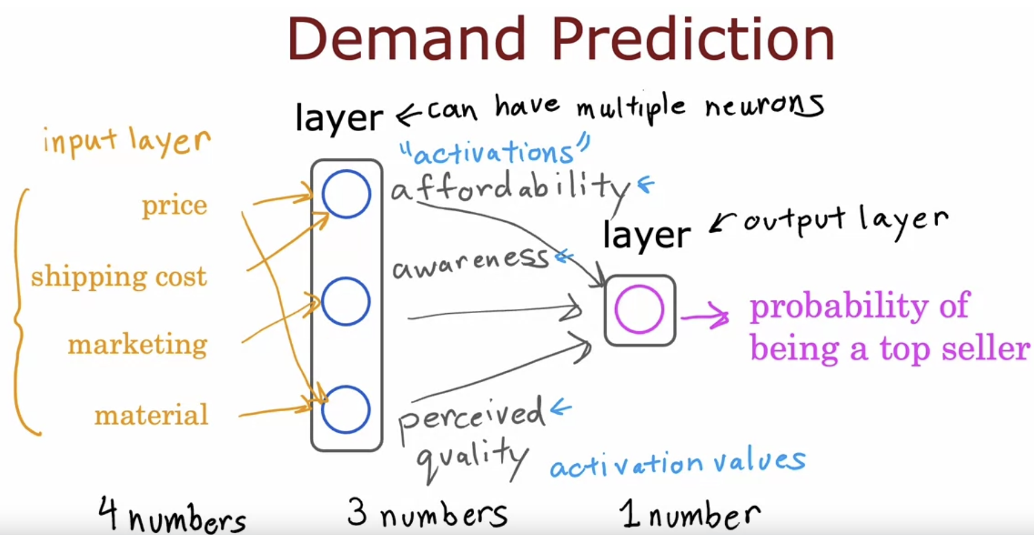

The term activations comes from biological neurons, and it refers to the degree that the biological neuron is sending a high output value or sending many electrical impulses to other neurons to the downstream from it.

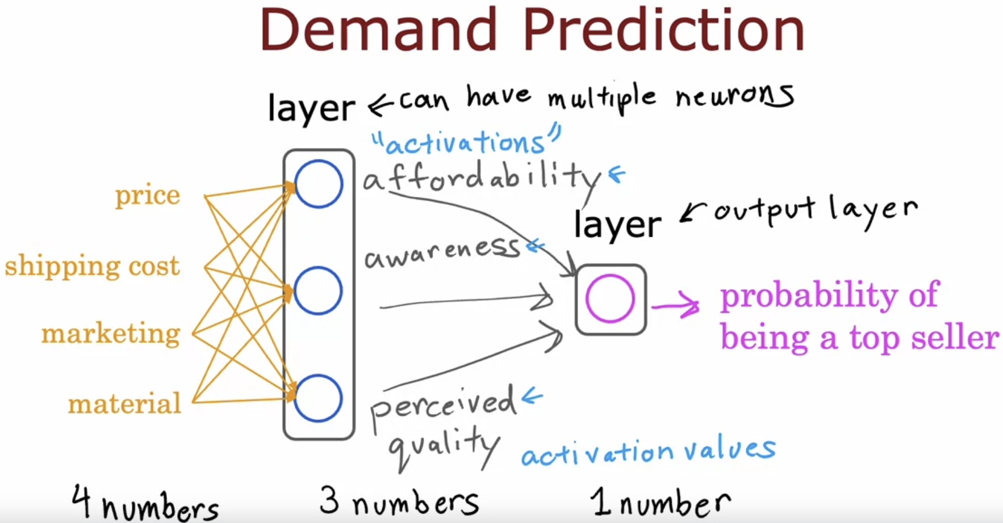  
Now the all the inputs are fed into the neuron.

**Hidden Layer**  
In a training set, you get to observe both x and y. Your data set tells you what is x and what is y, and so you get data that tells you what are the correct inputs and the correct outputs.

But your dataset doesn't tell you what are the correct values for affordability, awareness, and perceived quality. The correct values for those are hidden.

You don't see them in the training set, which is why this layer in the middle is called a hidden layer.

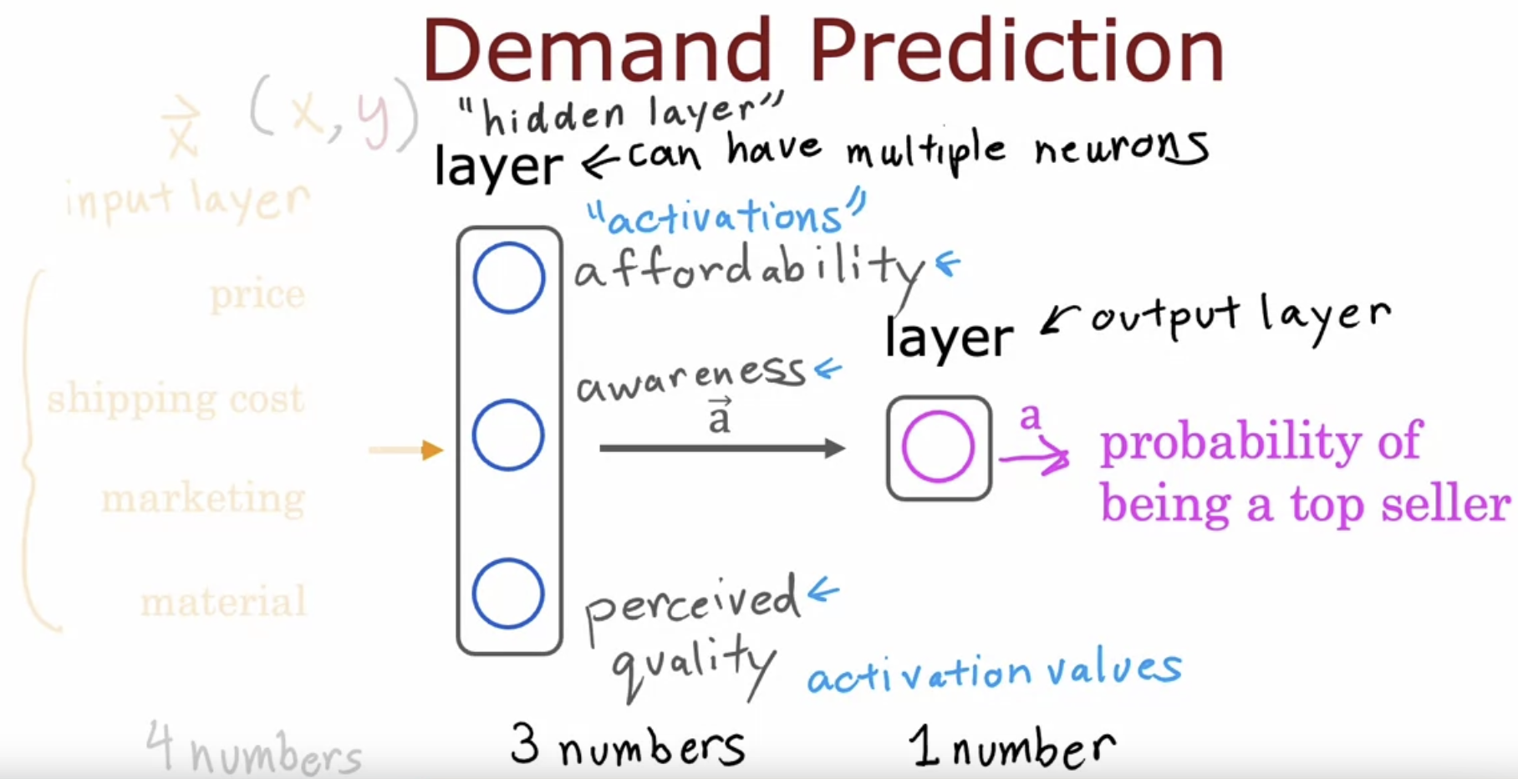

One way to think of this neural network is, just logistic regression.

But as a version of logistic regression, they can learn its own features that makes it easier to make accurate predictions.

In fact, you might remember from the previous week, this housing example where we said that if you want to predict the price of the house, you might take the frontage or the width of lots and multiply that by the depth of a lot to construct a more complex feature, x_1 times x_2, which was the size of the lawn.

There we were doing manual feature engineering where we had to look at the features x_1

and x_2 and decide by hand how to combine them together to come up with better features.

What the neural network does is instead of you needing to manually engineer the features,

it can learn, as you'll see later, its own features to make the learning problem easier for itself.

This is what makes neural networks one of the most powerful learning algorithms in the world today.

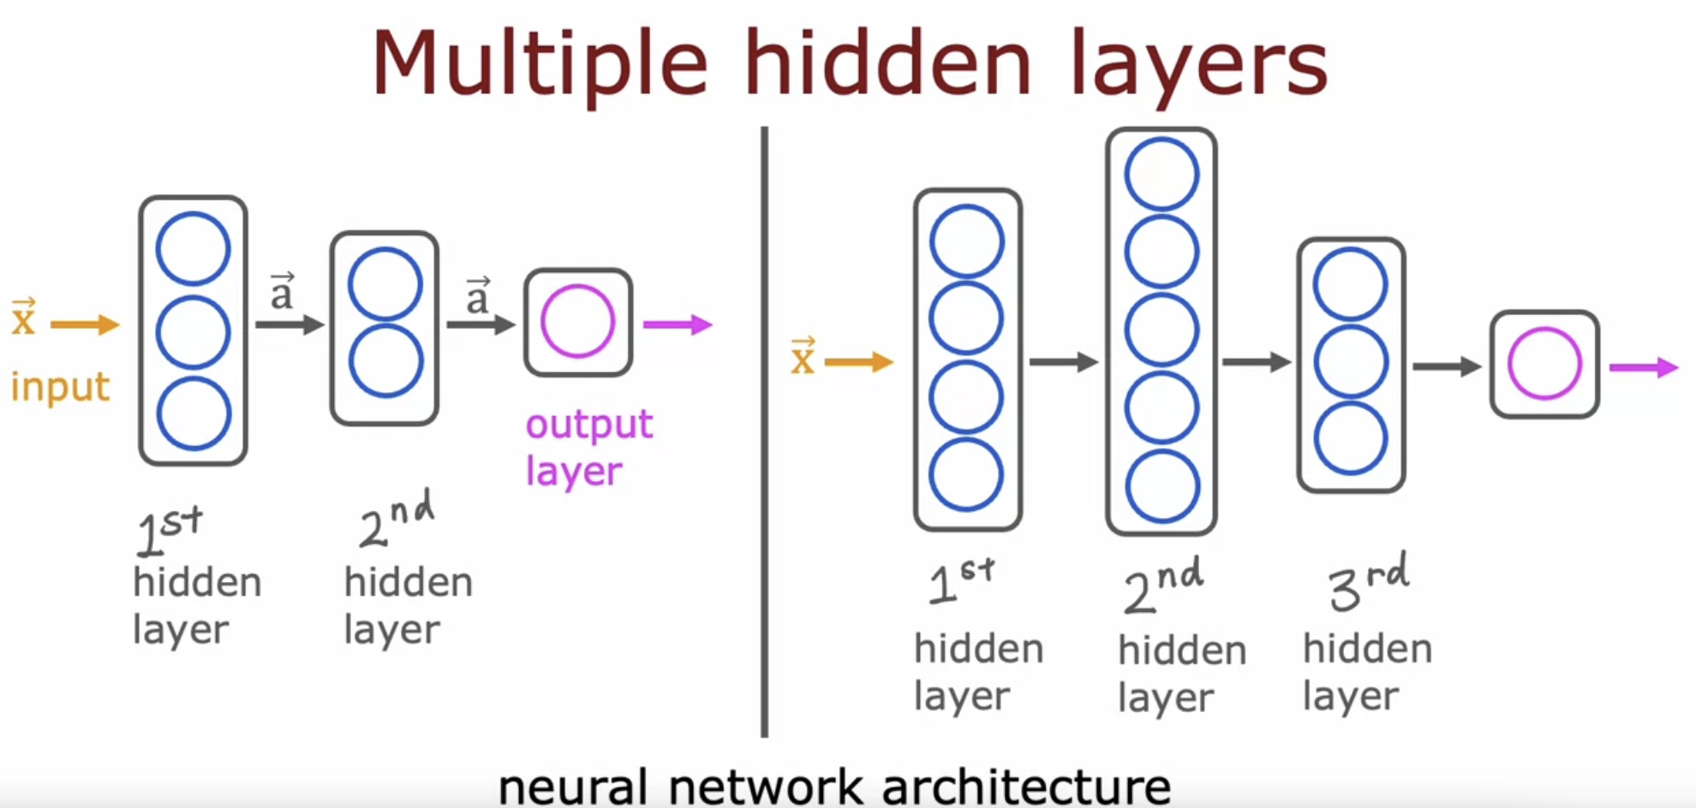

When you're building your own neural network, one of the decisions you need to make is how many hidden layers do you want and how many neurons do you want each hidden layer to have.

This question of how many hidden layers and how many neurons per hidden layer is a question of the architecture of the neural network.

# **Example: Recognizing Images**

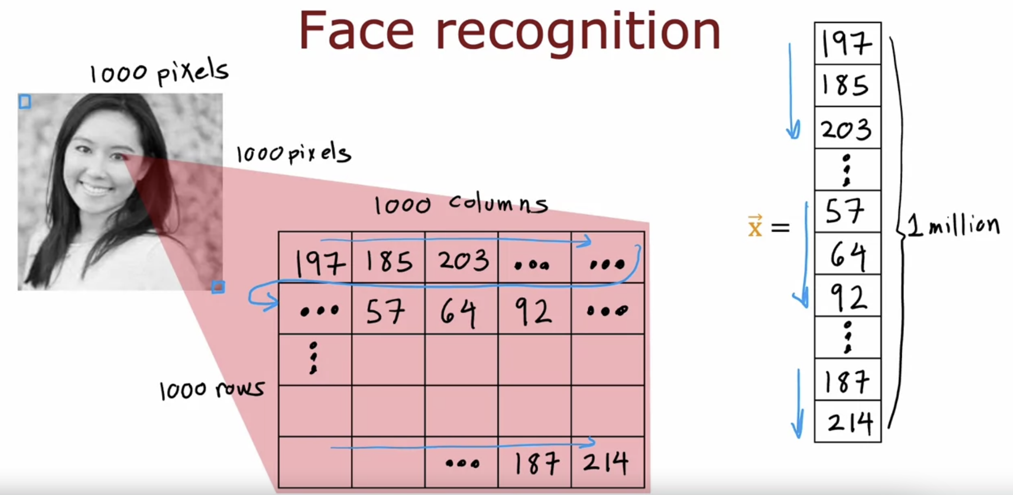

In the first hidden layer, you might find one neuron that is looking for the low vertical line or a vertical edge like that.

A **second neuron** looking for a oriented line or oriented edge like that.

The **third neuron** looking for a line at that orientation, and so on.   
In the earliest layers of a neural network, you might find that the neurons are looking for very short lines or very short edges in the image.

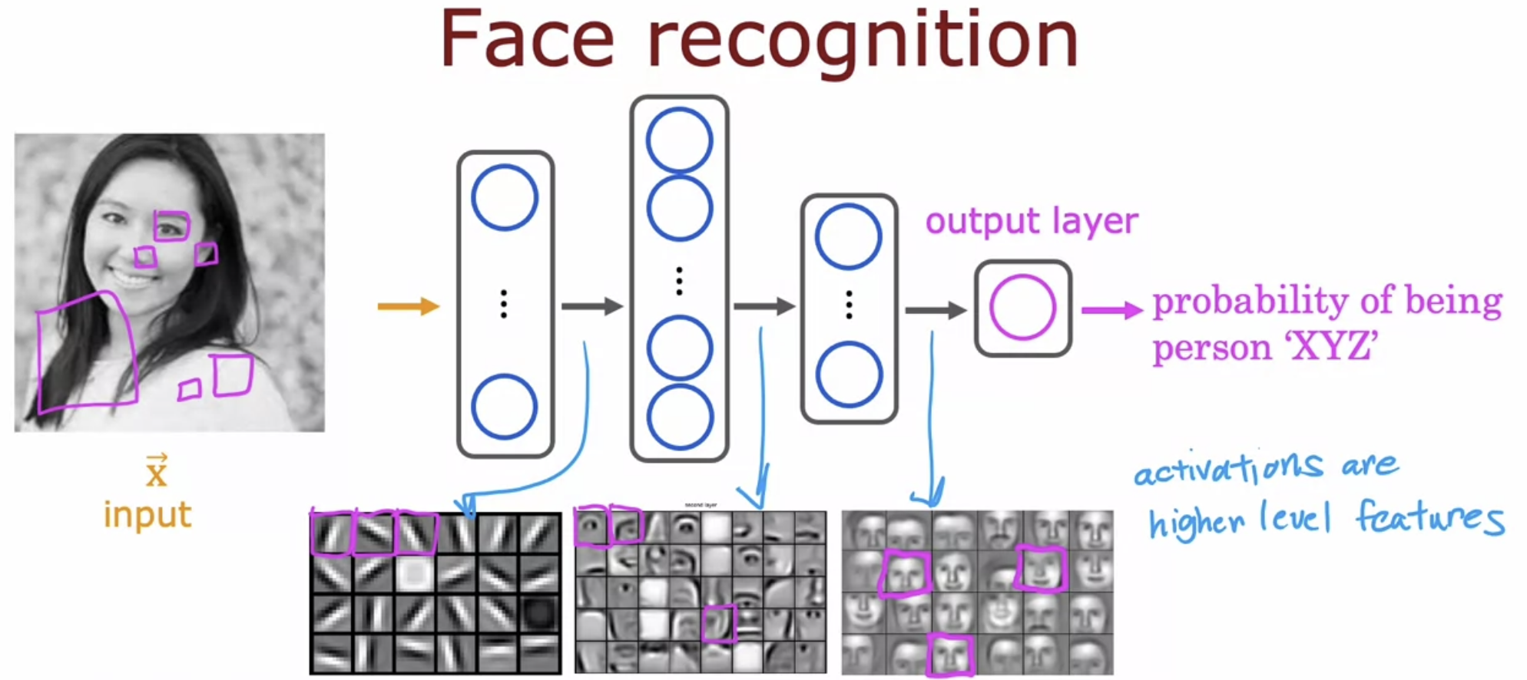

If you look at the next hidden layer, you find that these neurons might learn to group together

lots of little short lines and little short edge segments in order to look for parts of faces.

For example, each of these little square boxes is a visualization of what that neuron is trying to detect.

This **first neuron** looks like it's trying to detect the presence or absence of an eye in a certain position of the image.

The **second neuron**, looks like it's trying to detect like a corner of a nose and maybe this neuron over

here is trying to detect the bottom of an ear.

Then as you look at the next hidden layer in this example, the neural network is aggregating

different parts of faces to then try to detect presence or absence of larger, coarser face shapes.

Then **finally**, detecting how much the face corresponds to different face shapes creates a rich set of features that then helps the output layer try to determine the identity of the person picture.

A remarkable thing about the neural network is you can learn these feature detectors at the different hidden layers all by itself.

In this example, no one ever told it to look for short little edges in the first layer, and eyes and noses and face parts in the second layer and then more complete face shapes at the third layer.

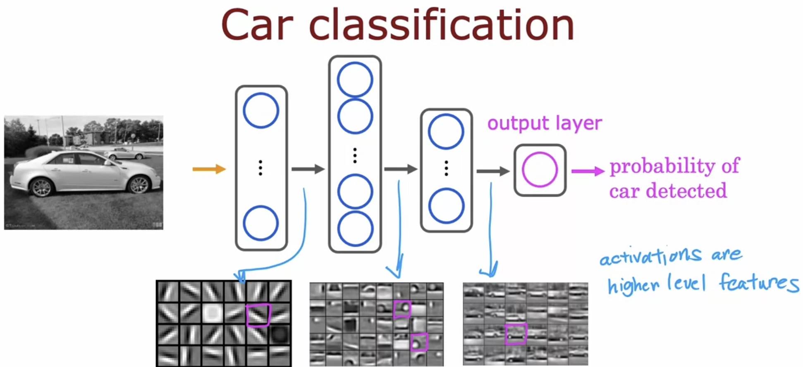

Just by feeding it different data, the neural network automatically learns to detect very different features so as to try to make the predictions of car detection or person recognition or whether there's a particular given task that is trained on.

# **Quiz**

